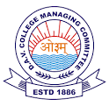 DAV PUBLIC SCHOOL NTPC FARIDABAD
CIRCULAR
Date-01.04.2023

Dear Students/ Parents

Greeting of the day!
Welcome in new session 2023-24 which will start from 03/April/2023
i.e. Monday
Note
1) Students should be in proper school summer uniform.
2) School timings will be 7:30 am to 2:00 pm.

Alka Arora
Principal

